# **How To Outsource Video Editing**

Outsourcing video editing refers to hiring a third-party company or individual to handle the video editing needs of a business. This practice allows companies to tap into specialized skills and resources without maintaining an in-house team of experts.

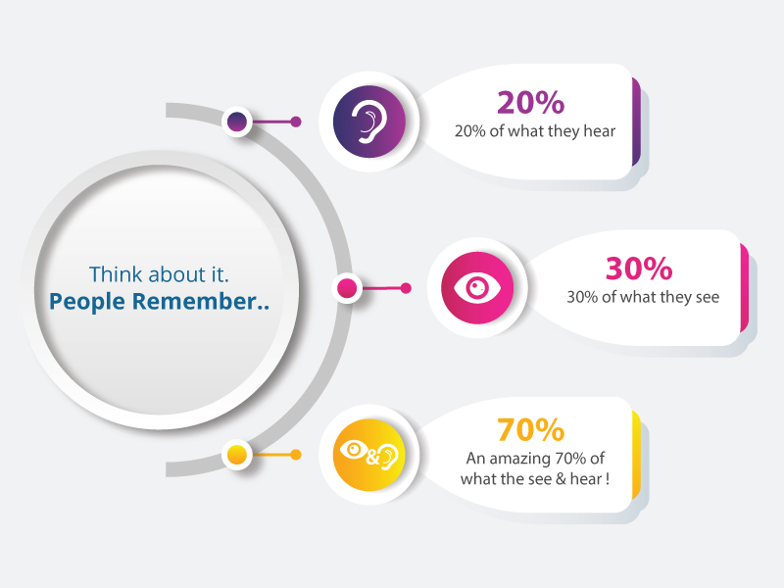

[Source](https://www.videocaddy.com/blog/wp-content/uploads/2019/11/work-2.jpg)

This article will guide you through the benefits, steps, and factors to consider when outsourcing video editing. It will also provide tips for success and insights into potential challenges.

## **Benefits of Outsourcing Video Editing**

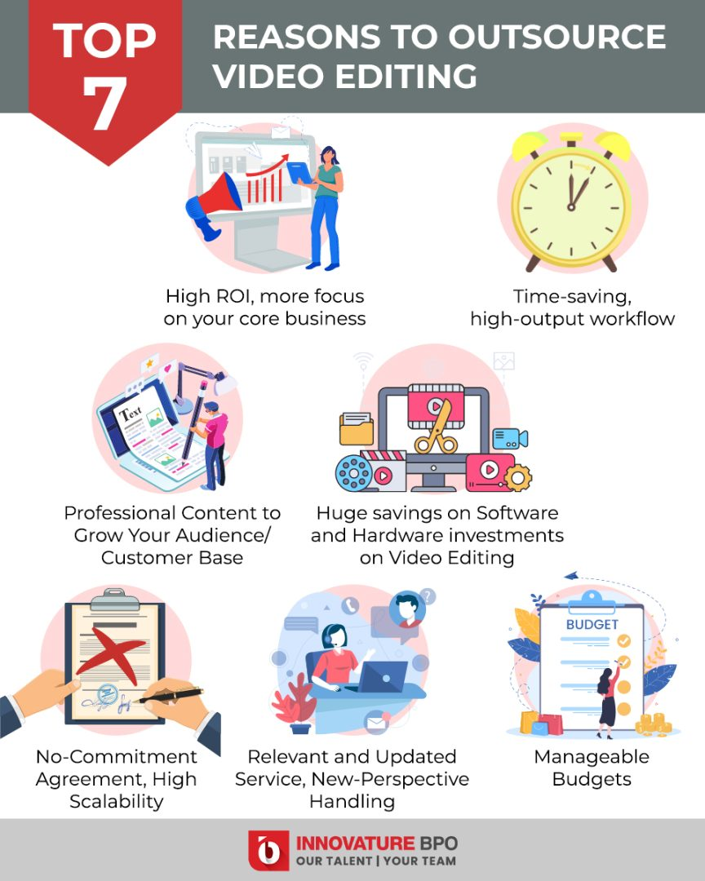

[Source](https://innovatureinc.com/wp-content/uploads/2022/06/top-7.jpg)

### **Cost Savings**

Outsourcing video editing services to a skilled video editor can significantly cut costs associated with hiring and maintaining a full-time editing staff. This reduction in expenses includes not only the salaries of the in-house team but also other associated costs like benefits, overhead fees, and even expenses related to video editing software. Outsourcing video editing services in this way allows for a more streamlined budget without compromising the quality of your video projects.

### **Improved Customer Satisfaction**

Outsourcing video editing means engaging with a video editing company or a freelance video editor who often possesses specialized expertise. This expertise from the video content creator allows them to craft high-quality products tailored to your needs. As a result, the finished product is often of a superior quality that aligns with the client's vision, enhancing customer satisfaction. The collaboration between your business and these skilled professionals can truly elevate the level of the video content produced.

### **Access to a Larger Pool of Talent**

You gain access to a wide range of talented professional video editors globally by seeking digital services for your video projects. Whether you require a full-time video editor or a more flexible arrangement, the diverse pool of talent ensures you can find the perfect match for your specific video editing needs. This includes creating engaging video content that resonates with your audience, reflecting quality and creativity. The global reach extends your options and possibilities, providing a tailored solution for your unique requirements.

### **Improved Efficiency**

With dedicated professionals handling the editing, your internal team can focus on other core tasks, improving overall efficiency.

### **Scalability**

Outsourcing your video editing allows you to quickly scale your editing requests up or down depending on demand. Whether you require a full-time editor for ongoing projects or specialized editing techniques for a one-time task, the adaptability of outsourcing can meet your needs. This flexibility ensures that you always have the right resources for your current demand, leading to a finished video that aligns with your expectations without the need to over-commit to permanent staff or resources.

### **Focus on Core Business**

By outsourcing specialized tasks to experts, you can concentrate more effectively on your company's core functions and business strategies. This enables you to allocate resources and attention where needed, enhancing productivity and efficiency.

### **Enhanced Competitive Edge**

Access to high-quality video editing services can give your business a significant competitive edge in the market. Leveraging professional expertise ensures that your content stands out, reflecting quality and creativity that can set you apart from competitors.

### **Risk Mitigation**

Outsourcing allows you to mitigate various risks associated with managing an in-house team, including employee turnover, training costs, and potential inconsistencies in output quality. By relying on specialized external resources, you can maintain consistent standards while minimizing potential internal challenges.

### **Flexibility and Customization**

Outsourcing offers tailor-made services designed to meet your specific needs and objectives. Whether you require particular editing techniques or customized content alignment with your brand, these services can be adjusted to suit your unique requirements. This ensures that the final product is not only of high quality but also fully aligned with your brand's identity and goals.

## **Steps for Outsourcing Video Editing Effectively**

### **1. Define Your Customer Service Needs**

Understanding your customer's specific needs, preferences, and unique objectives of the video editing project is a crucial first step. This knowledge forms the foundation for selecting the best outsourcing partner. By clearly defining what you hope to achieve, you can communicate more effectively with potential service providers and ensure a partnership that aligns with your goals.

### **2. Research Outsourcing Options**

Investing time researching various outsourcing options allows you to explore the diverse landscape of available services. This means looking at different providers, reviewing portfolios, conducting interviews, and even seeking references if needed. Such comprehensive research enables you to decide and find the right fit for your specific video editing needs.

### **3. Develop a Clear Communication Plan**

Creating a detailed communication plan is essential to a successful outsourcing relationship. This plan should outline the expectations, timelines, and specific guidelines or standards that must be adhered to throughout the project. By articulating these elements upfront, you can ensure that both parties are aligned from the beginning, minimizing potential misunderstandings or conflicts.

### **4. Implement and Monitor the Outsourcing Process**

Once the groundwork has been laid, it's time to kick off the project. This involves initiating the work and monitoring the process closely as it progresses. Regular check-ins, status updates, and adherence to agreed-upon milestones can help ensure the project stays on track. If any issues arise, they can be addressed promptly, keeping the project moving smoothly toward completion.

### **5. Ensure Security and Compliance**

Outsourcing often involves sharing sensitive information, so it's imperative to take robust measures to protect this data. This entails understanding and complying with all relevant regulations, whether legal or industry-specific. Furthermore, clear agreements regarding confidentiality, data handling, and security protocols should be in place. By being proactive in this area, you can foster a trusting relationship and minimize potential risks.

### **6. Provide Feedback and Support**

Building a successful outsourcing relationship goes beyond simply handing off tasks. Continuous collaboration, open dialogue, and regular feedback form a partnership that can evolve and adapt as needed. Whether it's constructive criticism or praise for a job well done, maintaining an ongoing conversation with your outsourcing partner encourages a more dynamic, responsive, and successful working relationship.

## **Factors to Consider When Outsourcing Video Editing**

### **Quality of Services**

Take the time to assess the quality of work carefully the outsourcing partner provides. This involves evaluating previous work, understanding their approach, and ensuring that it meets or exceeds your standards. Quality assurance measures should be implemented to maintain the excellence you expect throughout the project.

### **Availability and Accessibility**

When considering an outsourcing partner, consider their time zone, availability during your working hours, and ease of communication. Assessing these factors ensures that collaboration and communication can occur smoothly, reducing potential delays and misunderstandings.

### **Cost**

Thoroughly understand the overall cost of outsourcing, including potential hidden fees or additional expenses. Analyzing the complete financial picture and ensuring it aligns with your budget can help prevent surprises and allow for a more transparent and successful partnership.

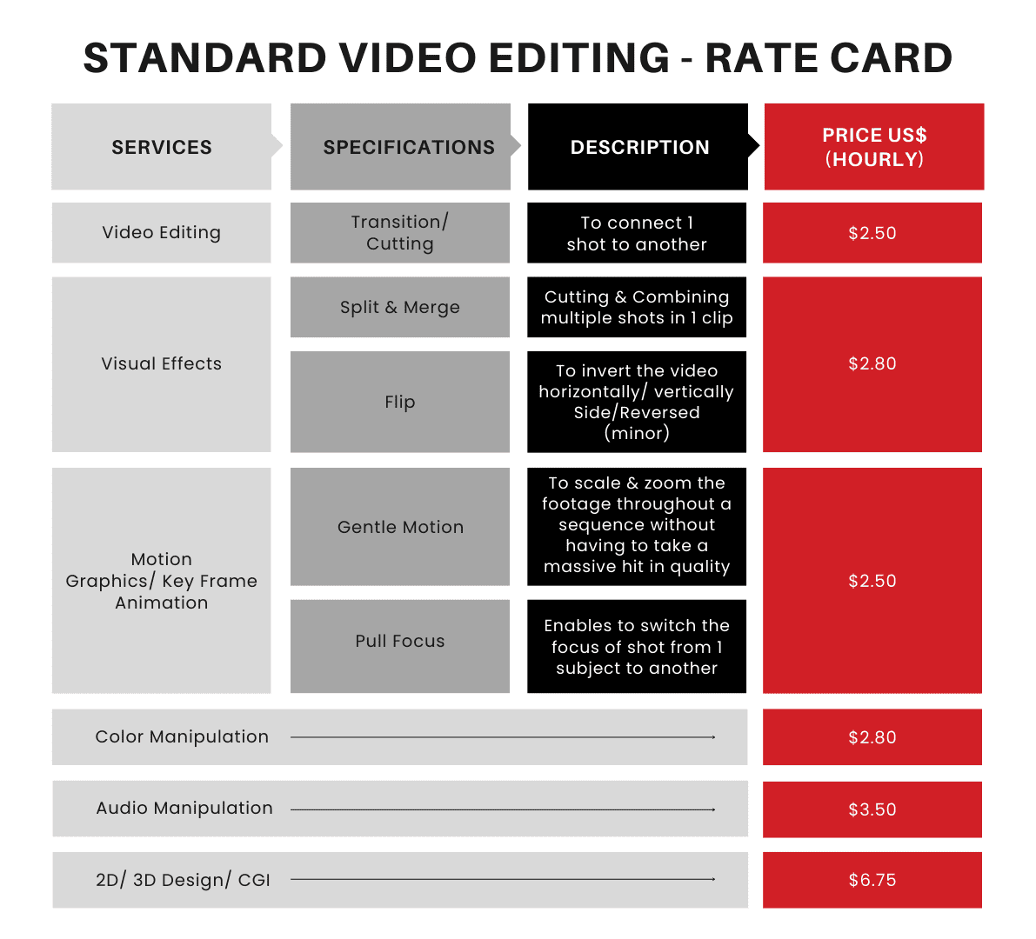

[Source](https://innovatureinc.com/wp-content/uploads/2021/05/chart-1.png)

### **Cultural Compatibility**

Cultural alignment is key to a successful outsourcing relationship. Ensure the outsourcing partner understands and aligns with your company culture, values, and expectations. This compatibility helps in maintaining a cohesive approach and contributes to a more productive working relationship.

### **Technology and Tools**

Evaluate the technology, software, and tools that the outsourcing partner uses. Confirm that they are up-to-date, reliable, and compatible with your systems. Using proper technology can enhance efficiency and collaboration, contributing to the project's success.

### **Intellectual Property Rights**

It is imperative to guarantee that proper agreements, contracts, and legal documents are meticulously prepared and put into place to safeguard intellectual property rights when engaging in an outsourcing partnership. This includes a clear and concise definition of ownership rights, usage rights, licensing agreements, and any other legal stipulations that pertain to the intellectual property involved in the project. By taking these precautionary measures, you are not only creating a legal framework that aligns with both parties' expectations but also building a robust defense against potential disputes or misunderstandings that might arise in the future. Such careful attention to intellectual property rights helps to protect valuable assets. It ensures that both parties are fully aware of their respective obligations and entitlements, contributing to a more secure and harmonious working relationship.

## **Tips for Successful Video Editing**

### **Foster Open and Clear Communication**

Promote an environment of open and transparent communication within the outsourcing partnership. Ensure that all communication channels are accessible, that regular updates and feedback are exchanged, and that all parties feel comfortable expressing their thoughts and concerns. Creating a clear pathway for communication fosters collaboration and mutual understanding, allowing for more seamless integration of efforts and alignment of goals.

### **Maintain a Consistent Brand Voice**

Uphold a consistent brand voice throughout the video editing by setting clear guidelines and expectations for the outsourcing partner. Ensure the edited videos align with your brand's unique voice, style, and overarching messaging. Regular communication and review processes can help maintain this consistency and ensure that the final product resonates with your target audience and adheres to your brand identity.

### **Use Technology to Your Advantage**

Embrace and leverage various technological tools and platforms to enhance collaboration, project management, and overall efficiency in the outsourcing process. You can create a more streamlined and effective method by selecting the right technology, customizing it to your specific needs, and integrating it into the workflow. This utilization of technology facilitates better coordination between parties and can introduce new opportunities for innovation and growth within the project.

### **Continuously Evaluate and Improve the Outsourcing Process**

Establish a consistent practice of regular evaluations, assessments, and reviews of the outsourcing process. These regular check-ins allow continuous progress monitoring, performance, and alignment with objectives. By actively seeking opportunities for improvement and making necessary adjustments, you create a dynamic and responsive outsourcing relationship. This ongoing commitment to evaluation and enhancement ensures the longevity of the partnership and contributes to the continued success and evolution of the project.

## **Potential Challenges of Outsourcing Video Editing and How to Overcome Them**

### **Language Barriers**

Language barriers can pose a significant challenge in outsourcing relationships. To overcome this, selecting a partner who is fluent in your language is essential, or at least a language both parties are comfortable communicating. Documenting expectations, utilizing translators when necessary, and employing communication tools that facilitate understanding can help bridge the language gap. Such measures ensure that language differences do not impede the successful execution of the project, maintaining clarity and alignment throughout the process.

### **Time Differences**

Time zone differences between you and your outsourcing partner may create scheduling and collaboration challenges. Address these potential issues by planning and coordinating schedules effectively. Open communication about working hours, regular updates, and collaborative tools that accommodate different time zones can help manage these differences. By proactively addressing time differences, you can foster a more harmonious and productive working relationship that caters to both parties' unique needs and constraints.

### **Maintaining Control Over the Customer Experience**

Retaining control over the customer experience within an outsourcing arrangement requires deliberate and continuous effort. Set clear guidelines, define expectations, and maintain close communication with the outsourcing partner to ensure alignment with your company's standards and customer experience goals. Regular monitoring, feedback, and adjustments can help shape the customer experience to match your vision, even when tasks are delegated to an external party.

### **Confidentiality Issues**

Protecting sensitive information is paramount in any business relationship, particularly in outsourcing. To safeguard this vital aspect, ensure that proper confidentiality agreements are in place, outlining the obligations and expectations regarding information handling, access, and security. Regular monitoring, secure data handling practices, and collaboration with legal professionals can reinforce these agreements, creating a robust framework to protect sensitive information and maintain trust between parties.

### **Quality Consistency**

Ensuring consistent quality across the project demands diligent attention and effort. Implement regular quality checks, maintain clear and transparent standards, and define processes for monitoring and evaluation. Collaboration with the outsourcing partner, continuous feedback, and a shared commitment to quality can further align efforts. By fostering a culture that prioritizes quality and consistency, you build a foundation for ongoing success, ensuring that the final product reflects the standards and expectations set at the beginning of the project.

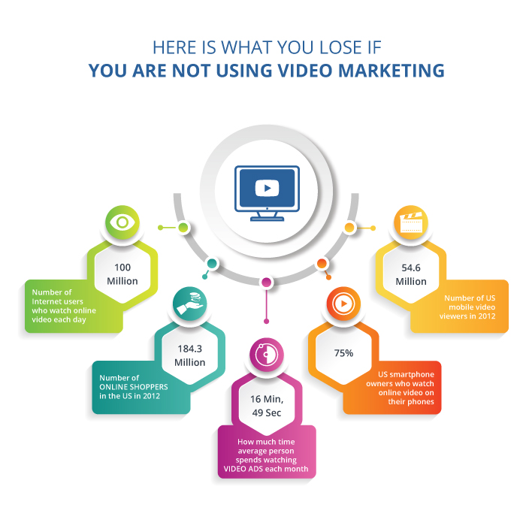

[Source](https://www.videocaddy.com/blog/wp-content/uploads/2019/11/work-1.jpg)

Outsourcing video editing offers numerous benefits, like cost savings, access to talent, and improved efficiency. Following the steps and considering the factors outlined will ensure a successful outsourcing experience.

### **Final Thoughts on Making a Successful Outsourcing Decision**

By understanding your needs, researching options, and maintaining effective communication, you can leverage outsourcing as a strategic tool for your video editing needs. It offers a flexible, efficient, cost-effective solution that significantly values your business.